**Bank Database**

create database Bank_database_159;

show databases;

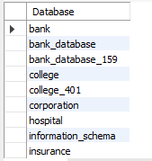

use Bank_Database_159;

create table Branch_159(branch_name varchar(30),

branch_city varchar(20),

assets real,

primary key(branch_name));

create table BankAccount_159 (

accno int,

branch_name varchar(30),

balance real,

primary key (accno,branch_name),

foreign key (branch_name) references Branch_159(branch_name));

create table BankCustomer_159(

customer_name varchar(20),

customer_street varchar(20),

customer_city varchar(20),

primary key(customer_name));

create table Depositer_159(

customer_name varchar(20),

accno int,

primary key(customer_name, accno),

foreign key (customer_name) references BankCustomer_159(customer_name),

foreign key (accno) references BankAccount_159(accno));

create table Loan_159(

loan_no varchar(20),

branch_name varchar(30),

amount int,

primary key (loan_no, branch_name),

foreign key (branch_name) references Branch_159(branch_name));

insert into Branch_159 values("SBI_Chamarajpet","Bangalore",50000);

insert into Branch_159 values("SBI_ResisdencyRoad","Bangalore",75000);

insert into Branch_159 values("SBI_ShivajiRoad","Mumbai",150000);

insert into Branch_159 values("SBI_ParlimentRoad","Delhi",100000);

insert into Branch_159 values("SBI_Jantarmantar","Delhi",35000);

insert into BankAccount_159 values(1,"SBI_Chamarajpet",2000);

insert into BankAccount_159 values(2,"SBI_ResisdencyRoad",2000);

insert into BankAccount_159 values(3,"SBI_ParlimentRoad",2000);

insert into BankAccount_159 values(5,"SBI_ShivajiRoad",2000);

insert into BankAccount_159 values(6,"SBI_Jantarmantar",2000);

insert into BankAccount_159 values(7,"SBI_Chamarajpet",2000);

insert into BankAccount_159 values(8,"SBI_Jantarmantar",2000);

insert into BankAccount_159 values(9,"SBI_ResisdencyRoad",2000);

insert into BankAccount_159 values(10,"SBI_ShivajiRoad",2000);

insert into BankAccount_159 values(11,"SBI_Chamarajpet",2000);

insert into BankCustomer_159 values('Avinash', 'Bull_Temple_Road', 'Bangalore');

insert into BankCustomer_159 values('Abhilash', 'Banerghatta Road', 'Bangalore');

insert into BankCustomer_159 values('Dinesh', 'MCL_Layout', 'Mumbai');

insert into BankCustomer_159 values('Chandan', 'Pritiviraj_Road', 'Delhi');

insert into BankCustomer_159 values('Balaji', 'ChandRoad', 'Delhi');

insert into Depositer_159 values('Avinash', 1);

insert into Depositer_159 values('Avinash', 2);

insert into Depositer_159 values('Abhilash', 3);

insert into Depositer_159 values('Abhilash', 5);

insert into Depositer_159 values('Dinesh', 6);

insert into Depositer_159 values('Dinesh', 7);

insert into Depositer_159 values('Chandan', 8);

insert into Depositer_159 values('Chandan', 9);

insert into Depositer_159 values('Balaji', 10);

insert into Depositer_159 values('Balaji', 11);

insert into Loan_159 values(1, "SBI_Chamarajpet", 1000);

insert into Loan_159 values(2, "SBI_ResisdencyRoad", 2000);

insert into Loan_159 values(3, "SBI_ShivajiRoad", 3000);

insert into Loan_159 values(4, "SBI_ParlimentRoad", 1500);

insert into Loan_159 values(5, "SBI_Jantarmantar", 1000);

select * from Branch_159;

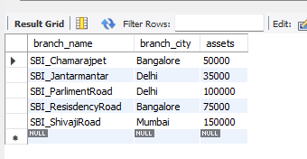

select * from BankAccount_159;

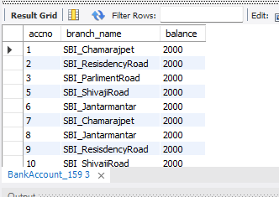

select * from BankCustomer_159;

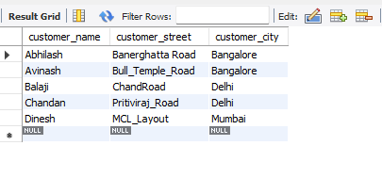

select * from Depositer_159;

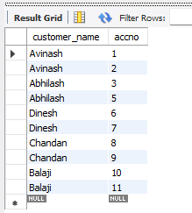

select * from Loan_159;

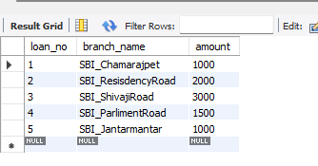

alter table Branch_159

change assets assents_inlakhs real;

select * from Branch_159;

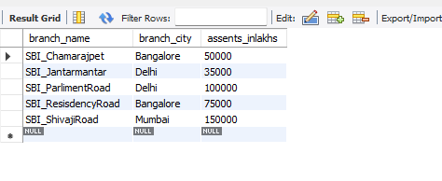

create view br

as

select branch_name, sum(amount)

from Loan_159

group by branch_name;

select * from br;

